7COM1079 - Team Research and Development Project

Final Report Title: Is there a statistically significant relationship between inflation rates and RTFP (Close) across countries between 2008 and 2020?

Group ID: A 83
Dataset Number: DS243
Prepared By: Mahi Patel – mp25aby@herts.ac.uk
Swayam Prajapati – sp25acy@herts.ac.uk
Karan Mori – km25adp@herts.ac.uk
Parth Goyani – pg25aap@herts.ac.uk
Ram Nadoda – rn25abb@herts.ac.uk

Contents
1 Introduction 1
1.1 Problem statement and research motivation 1
1.2 The dataset 1
1.3 Research Question 1
2 Background Research 2
2.1 Relevant research papers 2
2.2 Why the RQ is of interest 2
3 Visualization 2
3.1 Appropriate graphs 2
3.2 Plot explanations 3
3.3 Useful information 3
4 Analysis 4
4.1 Statistical test and justification 4
4.2 Hypothesis testing outcome 4
5 Evaluation – Group Experience 4
5.1 Points for improvement 5
5.2 Time management 5
6 Conclusions 5
6.1 Results explained 5
6.2 Interpretation 5
6.3 Future work & limitations 5
7 References 6

Introduction

Problem statement and research motivation
Macroeconomic instability and its impacts on productivity is one of the primary areas of concern of economic development research. Inflation, especially in the third world economies, may misguide investment decisions, diminish purchasing power and destroy the long run growth opportunities. Real Total Factor Productivity (RTFP) is an economical instrument of efficiency and competitiveness commonly used (Hulten, 2001). The study of the impact of inflation on RTFP offers an idea on whether price instability has an impact on the productive capacity of countries. The existing literature is an indication that high inflation may lower productivity due to uncertainty, misallocation, and less efficiency (Barro, 2013). Hence, this relationship should be investigated to guide policy makers, particularly in the nations where high rates of inflation are constant.

The dataset
The data set consists of monthly data of 25 countries in 2008 2020. The variables will be RTFP indicators (Open, High, Low, Close), inflation rates, country names, and ISO 3 codes and dates. Once missing data had been removed, 4,434 valid observations were ready to be used. The measure of productivity is the Close index. The range of inflation is quite diverse in the countries with the lowest inflation of -31.47% and the highest inflation of 363.1, and hence the dataset is appropriate to investigate the correlation between inflation and productivity.

Research Question
The research investigates whether inflation rates are associated with changes in national productivity levels. Specifically:
RQ: Is there a statistically significant relationship between inflation rates and RTFP (Close) across countries between 2008 and 2020?
Hypotheses
In order to get an answer to the research question, the following hypotheses were formulated:
H0 (Null Hypothesis): Inflation and RTFP have no statistically significant correlation (Close). Any relationship that is observed is because of random variation.
H1 (Alternative Hypothesis): RTFP is statistically significantly correlated with inflation (Close). This means that the level of inflation affects the productivity results in either a positive or a negative manner. Pearson correlation coefficient and linear regression were used to test the hypotheses. The analysis focuses on general relationship and country-specific ones.

Background Research

Relevant research papers
AI has already advanced to the level that the autonomous cognitive capacity of it, or, in other words, digital labor, must be considered as an independent factor of production instead of being hidden under Total Factor Productivity (Farach et al., 2025). Due to its intangibility, scalability, non-rival, fast changing, and replaceable by human labor, the conventional productivity metrics are unable to reflect the economic value of AI. The explicit incorporation of digital labor into growth models would enhance the manner in which firms evaluate the role of AI within growth, resource allocation and how structural contributors to growth operate. Inflation on the other hand keeps on depleting productivity in most settings.
Price escalation of necessities in Nigeria is a direct blow to the performance of workers by lowering real wages and bringing about insecurity due to underlying structural flaws (Bassey et al., n.d.). More general theoretical approaches, like the Cycle of Money theory, observe that, inflation occurs when the creation of money falls outside productive circulation (Challoumis, 2025). Empirical studies on Brazil reveal that productivity gains are not enough to curb inflation since companies tend to use them to increase markups (Piper et al., 2020). Latest inflation in the euro zone is an indication of import-price shocks and profit expansions, which proves the necessity of standardization of profits within t

Why the RQ is of interest
The research question is pertinent since inflation is a significant problem to most of the developing nations in the dataset. Negative effects of inflation on the efficiency of the economy are stressed in the prior literature, but there are few cases when cross-country monthly productivity data is studied in detail. This data set gives a chance to investigate the dynamics of inflation-productivity at high frequency. Moreover, the fact that there are extreme cases of inflation allows one to test the hypothesis that hyperinflation is related to fast drops in productivity. This relationship is useful in that it assists policy makers to develop more stability based economic policies and also adds to the current debate on the control of inflation and growth.

Visualization

Appropriate graphs
A scatterplot was chosen as the main visualization because it clearly illustrates the relationship between two continuous variables: inflation and RTFP (Close). A regression line was included to highlight the trend. A histogram of inflation was added as a supplementary graph to show the distribution of inflation levels.
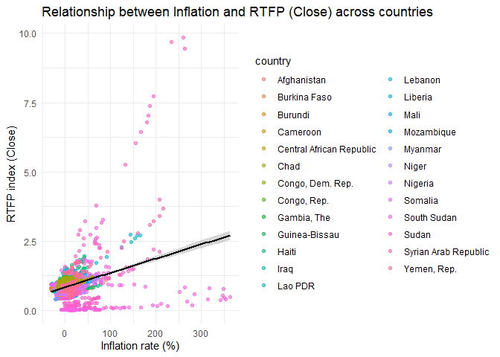

Plot explanations
The scatterplot indicates that there are clusters of countries characterized by low inflation and moderate RTFP and extremes of inflation with low productivity. The histogram gives an idea that the majority of the values of inflation are within the scope of -10% to 20 and the tails are very long displaying the periods of really high inflation rates.

Useful information
The histogram shows that the distribution is very skewed as there are a few countries that have a hyperinflation rate greater than 100. The scatterplot indicates a positive correlation, and increase in inflation is accompanied by a mild increase in RTFP, but this would be probably caused by extreme outliers like South Sudan and Sudan. The visual analysis shows that there is a significant difference between the countries.
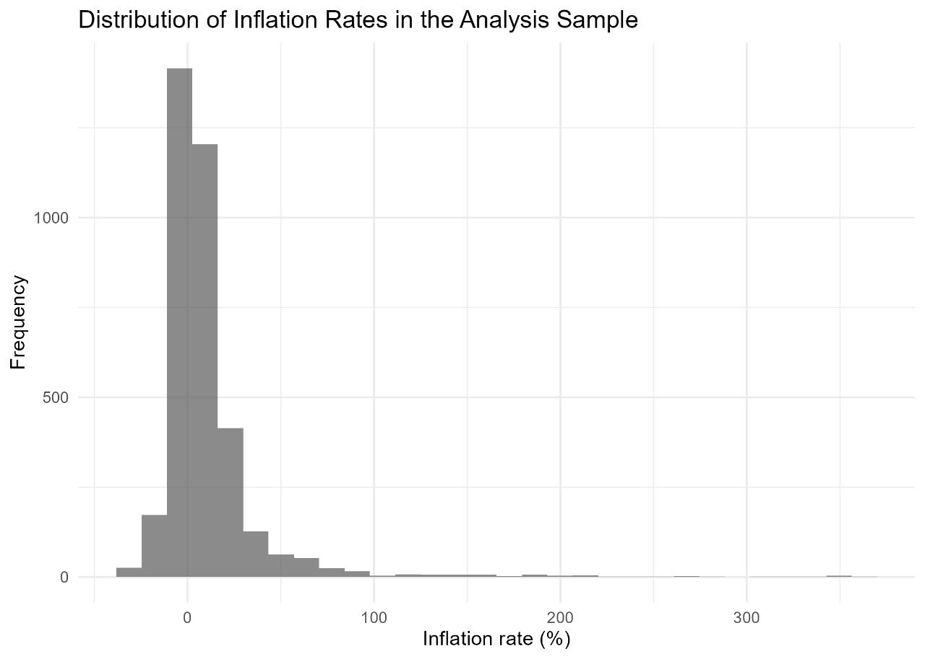

Analysis

Statistical test and justification
The correlation test employed by Pearson was employed to test the relationship between the two variables which are inflation and RTFP as the variables are continuous. The test is used to test the strength and direction of linear association. Besides, simple and fixed-effects linear regression models were also estimated to determine whether inflation could predict productivity when it is controlled by country-specific factors. Such tests are suitable to cross country panel data.

Hypothesis testing outcome
The Pearson correlation was positive and at p=2.2e-16, the correlation coefficient of 0.3304 was statistically significant. Thus, it rejects the null hypothesis. The regression analysis revealed that there is a small yet significant positive impact of inflation on RTFP (1 = 0.0051, p = 0.001). The effect was still significant when it was adjusted to the effect of country (0.0077, p < 0.001). The values of R-squared were, however, low (10.9% and 25.2%) indicating that the relationship is there but only a small share of the productivity variation is captured.

Evaluation – Group Experience
What went well
The team worked well in terms of task separation through data cleaning, R coding, report writing, and literature review. There was a uniformity in communication and version control was successfully handled with the help of GitHub. The generation of the visualizations and statistical analysis was also effective and the group made sure that the R code runs without errors. There was good preparation and task allocation in the project.

Points for improvement
The early dataset exploration should be improved, and first time was wasted on locating the missing values and verifying the date formats. Frequent meetings might have been used to synchronize the progress as well. Further experience using R visualization libraries would have enhanced the speed at which plots were created. And lastly, there could have been more focus on text interpretation of regression output before the finalization of text.

Time management
Time management had been enhanced during the project where tasks were done before the required time. The group however can also better planning by creating a bigger buffer time to incidents such as problems in data sets.
Overall project judgement
Overall, the project was successful, with clear results, functioning R code, and well-interpreted findings. The group gained valuable experience in statistical analysis and collaborative research.

Conclusions

Results explained
The correlation between the variable’s inflation and RTFP was statistically significant and positive, i.e. higher inflation is positively and slightly associated with higher reported productivity values. This small effect was upheld by regression models. Nevertheless, this correlation seems to be affected by some of the nations which have been suffering high inflation rates.

Interpretation
Although, both of them are positively associated with productivity, it does not mean that inflation enhances the performance of an economy. Rather, the severe cases of inflation can render the RTFP index inaccurate or indicate the fluctuations by crisis. The average productivity is manifested in most of the nations with stable inflation. Inflation is hence not to be taken as positive and the outcome must be viewed in the context.

Future work & limitations
The study is limited by the absence of inflation statistics and cross-country variance. Future studies ought to explore country-specific dynamics, take into account the effects of lagged inflation and incorporate institution-specific variables that can have an impact on productivity.

References
Bassey, E., Ingiagar, A., Esidene, G., & Ayiba Ojong, R. (n.d.). the Creative Commons License [CC BY-NC-ND 4.0] http://creativecommons.org/licenses/by-nc-nd/4.0 HIGH RATE OF INFLATION AND ADULT WORKERS’ PRODUCTIVITY IN THE SOUTHERN SENATORIAL DISTRICT OF CROSS RIVER STATE, NIGERIA. In LWATI: A Journal of Contemporary Research (Vol. 2024, Issue 1). www.universalacademicservices.org
Challoumis, C. (2025). The Inflation According to the Cycle of Money (C.M.). Economic Alternatives, 31(2), 324–353. https://doi.org/10.37075/EA.2025.2.03
Farach, A., Cambon, A., & Spataro, J. (2025). Evolving the Productivity Equation: Should Digital Labor Be Considered a New Factor of Production? http://arxiv.org/abs/2505.09408
Hansen, N.-J., Toscani, F., & Zhou, J. (2023). Euro Area Inflation after the Pandemic and Energy Shock: Import Prices, Profits and Wages. WP/23/131, June 2023.
Piper, D., Ferrari-Filho, F., & Lélis, M. T. (2020). The Relationship between Productivity and Inflation: An Empirical Analysis of the Brazilian Economy. Theoretical Economics Letters, 10(03), 563–578. https://doi.org/10.4236/tel.2020.103036

Appendix
library(tidyverse)
library(lubridate)
data <- read.csv("WLD_RTFP_country_2023-10-02.csv")

# Quick structure check
str(data)

# Convert date column to Date type (currently character)
data$date <- as.Date(data$date)

# Basic summary of all variables
summary(data)

# Count missing values per column
colSums(is.na(data))

# For correlation/linear model, we need rows with non-missing Close and Inflation
data_clean <- data %>%
filter(!is.na(Close),
!is.na(Inflation))

# How many rows remain?
nrow(data_clean)
data_analysis <- data_clean %>%
filter(date >= as.Date("2000-01-01"),
date <= as.Date("2020-12-31"))

# Check number of countries and date range used
length(unique(data_analysis$country))
range(data_analysis$date)
data_analysis %>%
select(Open, High, Low, Close, Inflation) %>%
summary()

# Country-level averages
country_summary <- data_analysis %>%
group_by(country) %>%
summarise(
mean_Close = mean(Close, na.rm = TRUE),
mean_Inflation = mean(Inflation, na.rm = TRUE),
sd_Close = sd(Close, na.rm = TRUE),
sd_Inflation = sd(Inflation, na.rm = TRUE),
n_obs = n()
) %>%
arrange(desc(mean_Inflation))

head(country_summary)

# Scatterplot of Inflation vs Close (colour by country)
p_scatter <- ggplot(data_analysis,
aes(x = Inflation, y = Close, colour = country)) +
geom_point(alpha = 0.6) +
geom_smooth(method = "lm", se = TRUE, colour = "black") +
labs(
title = "Relationship between Inflation and RTFP (Close) across countries",
x = "Inflation rate (%)",
y = "RTFP index (Close)"
) +
theme_minimal()

p_scatter

ggsave("plot_scatter_inflation_close.png",
plot = p_scatter, width = 7, height = 5, dpi = 300)

# Visualisation – supplementary histogram (Inflation)
p_hist <- ggplot(data_analysis, aes(x = Inflation)) +
geom_histogram(bins = 30, alpha = 0.7) +
labs(
title = "Distribution of Inflation Rates in the Analysis Sample",
x = "Inflation rate (%)",
y = "Frequency"
) +
theme_minimal()

p_hist

# Save histogram as PNG
ggsave("plot_hist_inflation.png",
plot = p_hist, width = 7, height = 5, dpi = 300)

#correlation between Inflation and Close by country
cor_by_country <- data_analysis %>%
group_by(country) %>%
summarise(
cor_infl_close = cor(Inflation, Close, use = "complete.obs")
) %>%
arrange(desc(cor_infl_close))

head(cor_by_country)

# Pearson correlation test between Inflation and Close
cor_test_overall <- cor.test(
x = data_analysis$Inflation,
y = data_analysis$Close,
use = "complete.obs",
method = "pearson"
)

cor_test_overall

# Simple linear regression: Close ~ Inflation
model_simple <- lm(Close ~ Inflation, data = data_analysis)
summary(model_simple)

# Regression with country fixed effects (controls for country differences)
model_fe <- lm(Close ~ Inflation + country, data = data_analysis)
summary(model_fe)

# Save table outputs as CSV for possible use in appendices
write.csv(country_summary, "country_summary.csv", row.names = TRUE)
write.csv(cor_by_country, "cor_by_country.csv", row.names = TRUE)

